**New Tech *fiber optic cable consultant***



**Technical Recommendations for Deployment of HDPE DUCTs**

**Landing station at Karachi**

**Muhammad Adil**

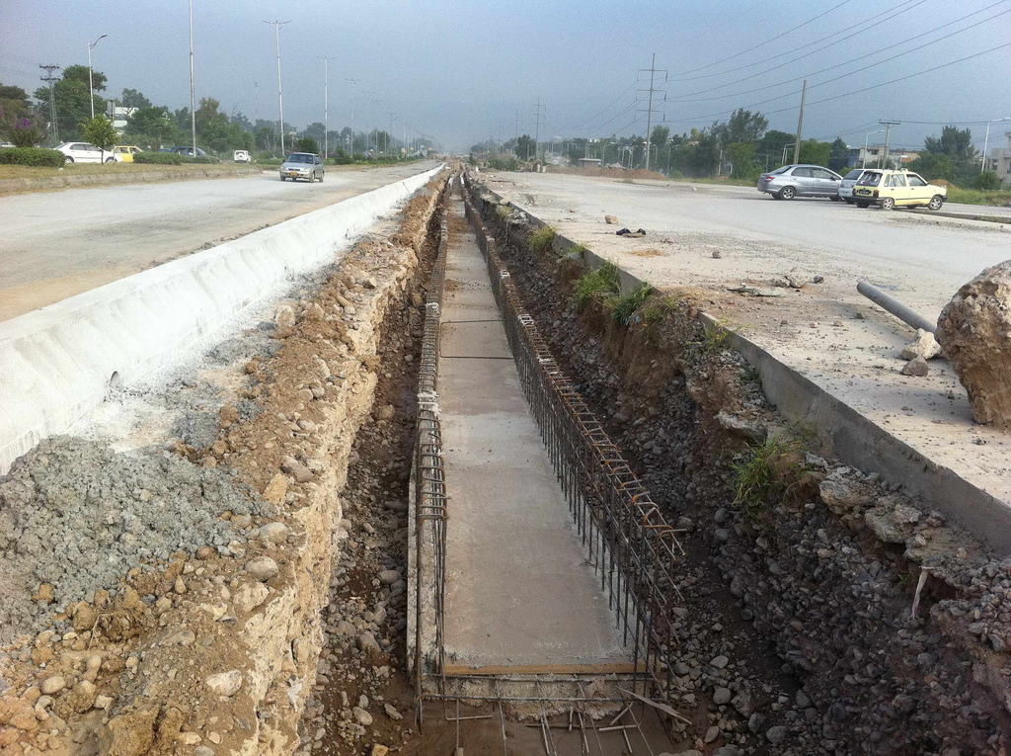

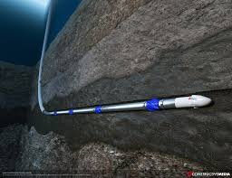

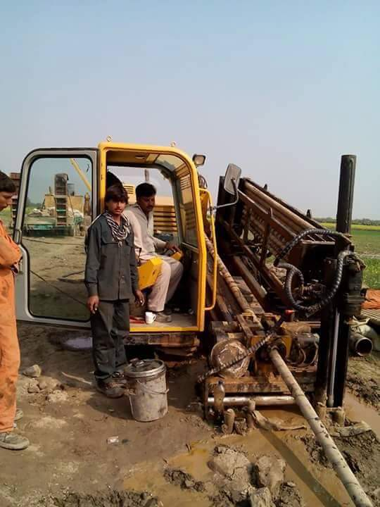

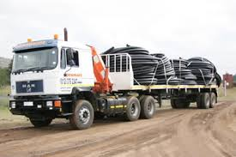

1. **Ducts**
2. Underground duct ways are required to connect the manholes from one to another and to the nearest fixed network communications access points communication cabinet, communication room, local exchange and etc. The number of duct ways is dependent upon the size and types of connection and number of potential users/customers in the development areas.
3. Developer is strongly advised to consult the Fixed Network Service Provider on the appropriate selection of the number of duct ways to be provided as to accommodate their requirements in the deployment of the communications facility in the development area.

# Scope of Work

CUSTOMER intends to build a duct network to pull optical fiber cable from cost side to CUSTOMER landing station at Hawksbay, with the options of one HDPE pipe of 110mm sub ducted with two 38mm pipes or deployed two HDPE pipes of 50/33mm.

# Location/Soil

Soil is sandy and water table is very high, prefabricated Manhole and hand hole are proposed to be placed immediately making manhole pit at site.

# Pre-Dewatering of Site

1. Excavation initially commenced with no dewatering provision in place hoping to find away to install the HDPE pipes before water gets into the excavated trench. However, closeness to the Caspian Sea caused massive volumes of water to infiltrate through the permeable sand towards the excavated trenches causing significant construction difficulties. Several suction pumps had to be continuously used to dewater the trench so that the construction of manholes or installation of HDPE pipes could be carried. It was realized during construction that the saturated sandy soil is unstable and excavation cannot be performed without the application of prior stabilization technique, such as soil freezing, grouting or dewatering. Soil freezing could not be employed in this project due to the high cost and lack of qualified expertise. A pilot test on the application of a viable grouting technique also failed because of inefficiency of ordinary grout injection in the existing cohesion less soil which required special treatment. Therefore, the utilization of pre-dewatering system along the excavated strips was unavoidable.
2. Due to lack of space in the congested streets, open pumping technique using drains and ditches could be utilized. Instead, a concise pre-drainage technique which involved the installation of an efficient dewatering system (typically located outside of the excavated area) implemented prior to excavation was recommended.

# Use of trench boxes

1. For the loose sandy soil with zero cohesion existed at the site, the use of trench boxes within the excavated area deemed effective as they do not rely on the passive resistance of the soil. To comply with the minimum safety requirement and ease of working conditions, portable steel trench boxes were first used to support the sides of the excavated trenches. A series of trench boxes (also called a trench shield) were progressively placed in the excavated strips to prevent wall movement from disrupting the excavation process and injuring workers. As illustrated in Fig. A, the trench box consisted mainly of two large steel plates parallel to the walls of the trench, and horizontal cross-members holding the two plates apart. The lower edge of the box rests on the bottom of the trench, and the top edge extends above the ground surface. The workers stayed between the plates of the trench box, so that if the excavation wall collapses, the soil would be stopped by the presence of the box. As work progresses, the trench boxes are removed and prepared for reuse in the next sections.
2. Although the initial excavation size was slightly larger than the width of the box, as the excavation progresses, the loose sand that had no stand-up time moved rapidly filling up the gap behind the walls and the supported soil leading to the development of active and passive pressures. The active lateral pressure was assumed to develop on the sides of the box as the soil mass is allowed to stretch sufficiently to mobilize its shear strength. However, the initial trench boxes failed to cope with the soil movement causing damage to the boxes and interrupting the installation process as illustrated in Fig. B.

Fig: A

Fig-B

# Two-stage Excavation Procedure

# Another interesting approach that is proposed in this project is the construction of two-stage deep cuts proved to be a very successful practice in places where Customers could afford to have a wider access to the exaction strips. In a first run a wider shallow trench would be excavated to be used as platform for the second box protected deep cut to the required grade as illustrated in Fig. C. This simple approach was very welcomed by the customer’s since no extra equipment was involved. However, this technique highly relies on the skills of the well experienced machine operator and almost cost double. In fact, a continuous in- trench dewatering along with two-stage deep cut proved as the most successful sewer installation approach in comparison to the other observed experiences in this sandy soil.

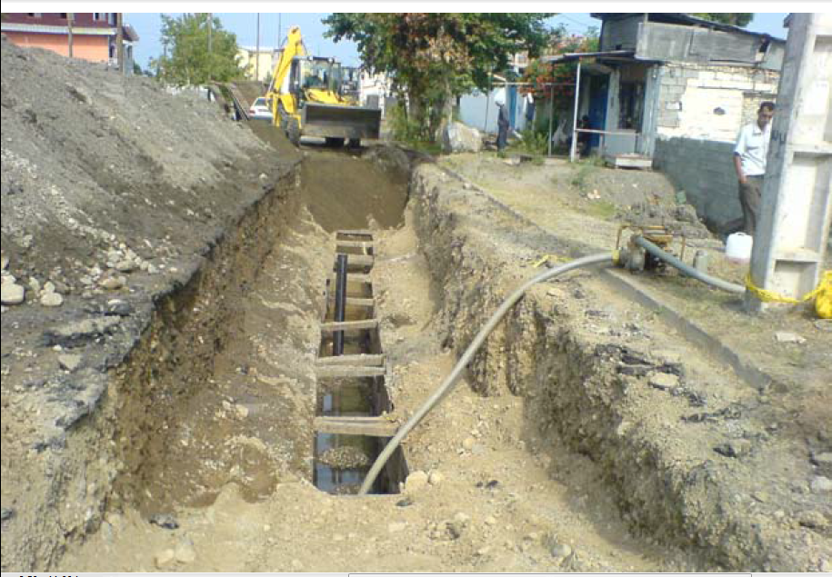

Fig C

# Duct network

1. Underground duct ways are required to connect the manholes from one to another and to the nearest fixed network communications access points, communication cabinet, communication room, local exchange and etc. The number of duct ways is dependent upon the size and types of connection and number of potential users/customers in the development areas.
2. The use of a single duct maximizes the number of cables that can be installed but full ducts make it difficult to extract older cables (typically at the bottom of the duct) to create room for new cables. Using sub-duct may reduce the total number of cables that can be installed, but at least older cables can be removed and new ones installed. It also allows the use of cable blowing as well as cable pulling, since it is easier to obtain an airtight connection to the sub-duct.
3. Typical duct sizes are 110mm, 100mm or 90mm for main duct and 57/50mm, (57mm outer diameter, 50mm inner diameter) 50/43mm, 40/33mm, 33/26mm or 25/20mm for sub-duct. Cables are installed into the ducts by pulling, blowing or floating. If they are to be pulled, then the duct either needs to contain a pre-installed draw-rope or to have one installed by Roding and roping. The cable diameter should not be too large compared to the duct inner diameter. Fill ratios should be calculated as part of the planning process. For cable blowing operations the duct joints must be airtight. For existing networks the condition of the ducts should be checked for any potential damage and suitable space and capacity for future cabling.

Multiple Ducts with Spacers

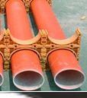

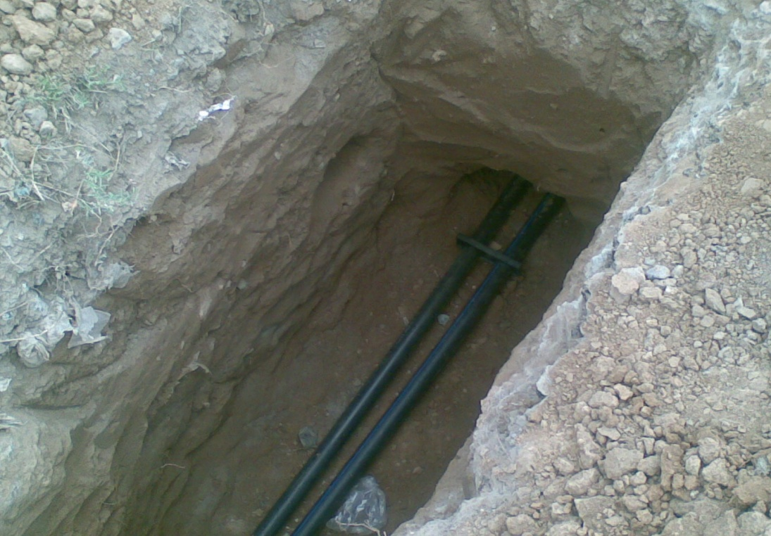

1. **Recommendations:**

**On basis of given information it is recommend to deployed two HDPE ducts with spacers, which are more easy to installed and maintained for longer period. In future these ducts are further sub ducted if required**